

Requirements for Making Accessible PDF Documents with Adobe Acrobat X (Professional) at the U.S. Department of Education

February 2012
Version 1.0



Requirements for Making Accessible PDF Documents with Adobe Acrobat X (Professional) at the U.S. Department of Education
Assistive technology is used by individuals to help them understand electronic information. For example, screen readers or text-to-speech software is one tool available and assists individuals who are blind, have low vision, or a learning disability. This special technology interprets words on the page and translates them to a computerized voice that reads the information. You may have heard the name JAWS or Window-Eyes as these are some examples of this assistive technology. Accessible documents work in partnership with assistive technology to ensure individuals with disabilities have access to information.
Listed below are basic PDF Requirements that help make documents accessible in Adobe Acrobat X (Professional) and come from Section 508 of the Rehabilitation Act. The Department has identified sixteen requirements that are divided into four major categories:
- Document Layout and Formatting,
- Document Images,
- Document Tables, and
- Other.

The majority of these requirements provide an underlying technical structure so that they can be used effectively by assistive technology. When you create an accessible document, you are using methods that make a document usable by individuals with any type of disability. A little change on your part to use built-in features makes a big difference for individuals with disabilities.
NOTE: It is usually easier to remediate the source document (Word, PPT, or Excel) according to the ED requirements found at http://connected/index.cfm?cid=12b93199-93a9-67c1-5cfa-21e5c3ea4202. Once remediated, checking against the following requirements is easier. However, when obtaining the source document is not possible or when the source document is outside of the formats listed above, then the following requirements will still allow you to create an accessible PDF document.
Adobe Acrobat X (Professional) has a built in accessibility checker. However, the rules in the accessibility checker do not match the requirements at the Department. Therefore, the checker can be helpful in identifying some issues (i.e., missing alternative text, etc.), but a document will not be considered accessible until it adheres to all the requirements listed below.

Document Layout and Formatting

DO:

Do ensure that accessibility tags are present and correctly identified.
A document without tags is not accessible. However, it is not enough for tags to be present, tags must correctly identify the visual layout of the document because these tags indicate the document structure.
Tags identify the type of content such as a figure, paragraph, or list. For example, if your document is a letter with an ED logo, paragraphs, and a list, then the tag tree (shown on the left side of the example) must have those same elements. In this example, the tag tree correctly identifies the logo as a <Figure>, the various paragraphs as <P>, and the bullets as list <L> tags.
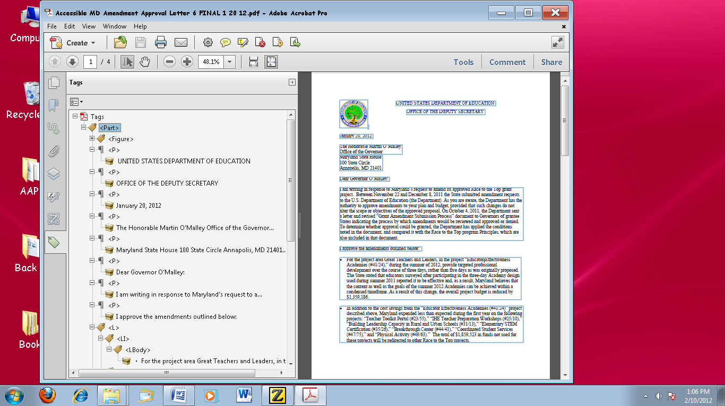
You can open the tag tree by selecting “view,” “Show/Hide,” “Navigation Panes,” “Tags.” In order to see all the tags, press “Ctrl” and click on the box with the plus sign. Finally, you can set up the application to highlight content related to the tags by clicking on the downward arrow in the Tags pane and selecting “Highlight Content”. The most common tags are identified below.

Headings
Do ensure heading tags are present in multiple page documents and make sure that the headings follow in a hierarchical manner (i.e., Heading 1 (<H1>) comes before Heading 2 (<H2>) then Heading 3 (<H3>) etc.). In addition, make sure not to skip heading levels. For example, don’t jump from <H1> to <H3>.

References
When documents contain references, ensure they are associated with the proper tag. Some examples include: annotations (<Annot>), bibliography entry (<BibEntry>), caption (<Caption>), index (<Index>), note (<Note>), reference (<Reference>), table of contents (<TOC>) and table of contents item (<TOCI>).

Lists
Ensure that lists are associated with a list tag (<L>). Also, ensure that the items within the list are associated with list item tags (<Li>) and list body tags (<LBody>.
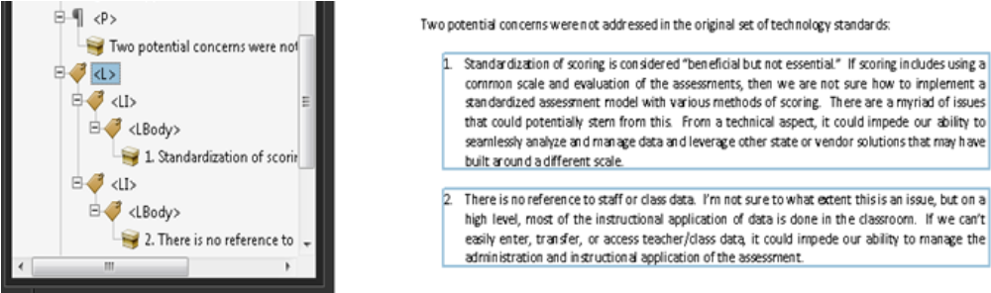

Tables
Ensure that each table is associated with a table tag (<Table>). Also, ensure that the items within the table are associated with proper tags: table header cell (<TH>), table row (<TR>), and table data cell (<TD>).

Headers and Footers
If header/footer areas contain redundant information, then tags are not necessary. For example, if the Title of the Document is listed on the First page and repeated in footer areas on every page, then the footer area contains redundant information. However, if the Department’s address appears in the footer area and it’s not listed anywhere else in the Document, then it must have a corresponding tag.

Paragraphs
Ensure that paragraphs of text are associated with paragraph tags (<P>).

Non-text Elements
Ensure that non-text elements are tagged. For example, images are associated with figure tags (<Figure>).

Do ensure that the document is structured to show a logical reading order.
PDF tags also indicate the reading order of the document when used by assistive technology. You can inspect the document to ensure the content is in proper reading order – meaning the content order matches the visual layout or the desired layout – by opening the tag tree, setting the application to highlight content, and then “walking” down the tag tree to ensure that the tags match the visual layout. In the example below, the reading order is proper because it matches the visual layout. However, if the figure tag was listed after the paragraph tag which contains the “U.S. Department of Education”, then the tags would not match the visual layout and you would want to adjust the order of the tags.
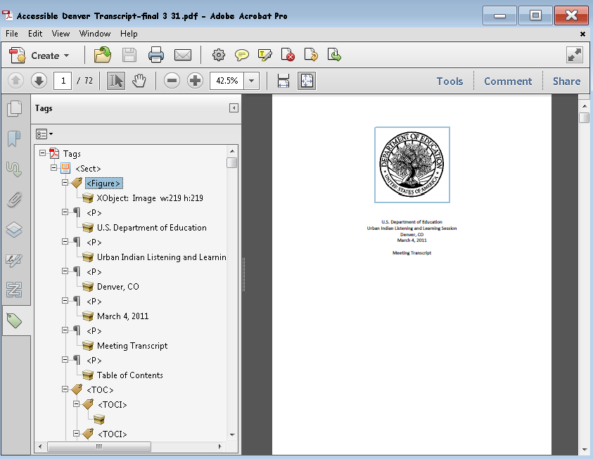

Do ensure all URLs are tagged properly.
The tags panel should contain a <link> tag that corresponds to the hyperlinked text in the document. There are three elements for an accessible link: the link tag (<Link>), the link object tag (<Link – OBJR>), and the tag listing the URL. The last two tags must be nested under the link (<Link>) tag. See the example listed below.
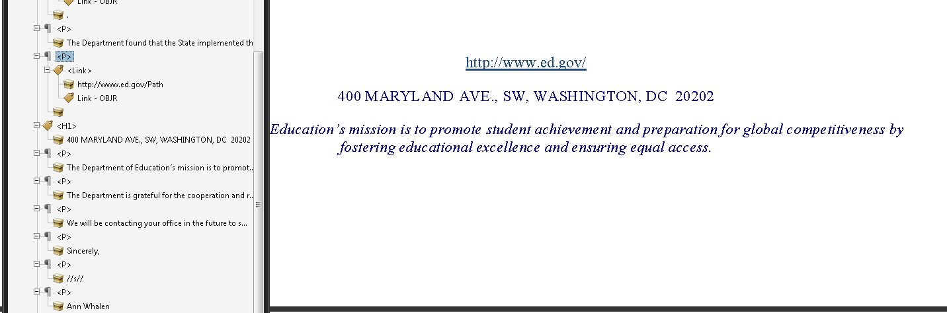

Do ensure all links work (are linked to active Web destinations).

DO NOT :

Do not rely on color-coding as the only means of conveying information or distinguishing a visual element.
Color is useful in conveying important information. However, when color alone is used to convey meaning (i.e., making a section of text red), then a person who is blind or colorblind will not have access to the information. Therefore, color alone will not make information accessible. A remedy would be to use color and another indicator.

An Example of using color and another indicator
Below is a list of participants with the winner denoted with * and highlighted in red.
Ann Jones
Jim Cane*
Janis Poole

Do not use blinking text, objects, or other elements having a flash or blinking frequency between 2 Hz and 55 Hz.

Document Images

DO:

Do provide a text equivalent for every non-text element.
Documents are usually a combination of text and non-text elements (i.e., images, photos, charts, graphical text or audio files). Because a screen reader cannot read a non-text element, it is important to include text equivalents so that people using assistive technology have access to the graphical elements. Text equivalents are referred to as “alt text” or alternative text and describe the information in a non-text element.
You can add or edit Alternative Text by using the TouchUp Reading Order panel. Select “View”, “Tools”, “Accessibility”. In the open Tools panel, click on “TouchUp Reading Order” under “Accessibility”. Right click on the highlighted figure and click on “Edit Alternate Text”. Enter the Alternate Text in the box provided. Once you’ve entered the information, make sure you select “OK”.
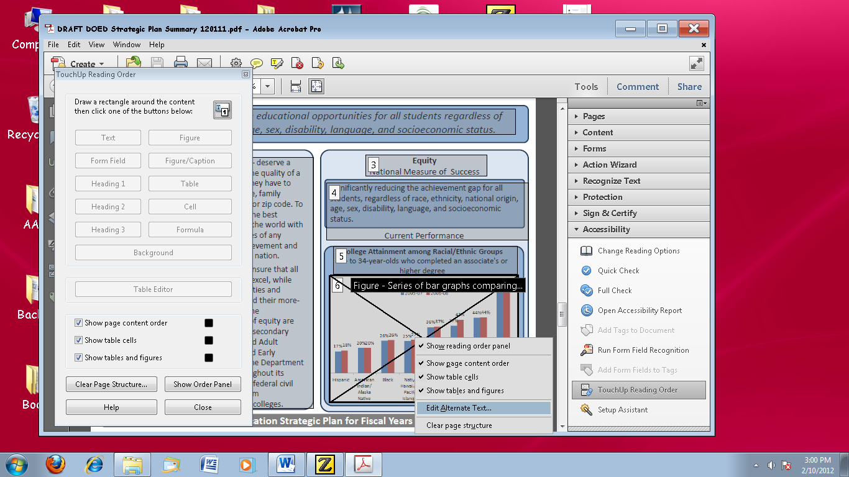

Do ensure multiple associated images (i.e., Organizational Charts) are grouped as one object and use one alternative text (alt tag) for the image.
When creating a document image with multiple associated images, instead of providing an alternative text for each individual component, you must group the images together and then provide one alternate text for the whole image.
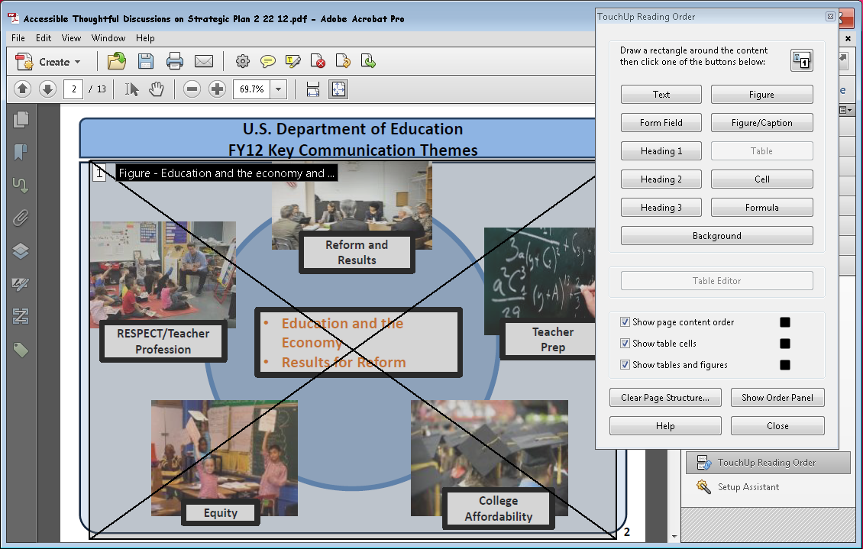
With the touchup reading order tool open, select each of the separate images with your mouse while holding down the control key. All of the images will become highlighted. Next click the figure button on the touch up reading order tool and they will become one image as shown in the screenshot above. Insert alternative text as described above.

Do ensure that complex images, diagrams or charts have descriptive text immediately after the image or in an appendix.
When remediating a complex image, diagram or chart, it may not be possible to create an alternative text that sufficiently describes the object. Therefore, it would be necessary to provide descriptive text immediately after the image or in an appendix. See the example below.

Example Figure 2:
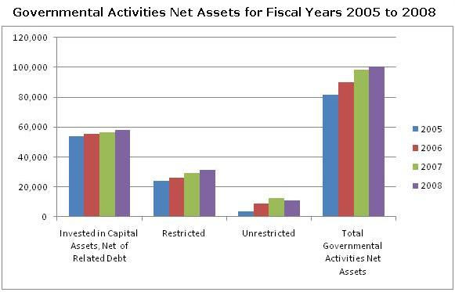

The table below shows the data for Governmental Activities Net Assets for Fiscal Years 2005 to 2008 with amounts in millions of dollars:
GOVERNMENTAL ACTIVITIES | 2005 | 2006 | 2007 | 2008
Invested in Capital Assets, Net of Related Debt | 53,815 | 55,473 | 56,438 | 58,208
Restricted | 24,110 | 25,993 | 29,347 | 31,358
Unrestricted | 3,753 | 8,696 | 12,565 | 11,105
Total Governmental Activities Net Assets | 81,678 | 90,162 | 98,350 | 100,671

Document Tables

DO:

Do ensure that cells (containing ‘data’) within the first row or column are designated with ‘Header Tags.’
In PDF, a column or row header is identified with a Table Header (<TH>) tag. Therefore, you must ensure that each cell in the row or column header is identified with a <TH> tag.
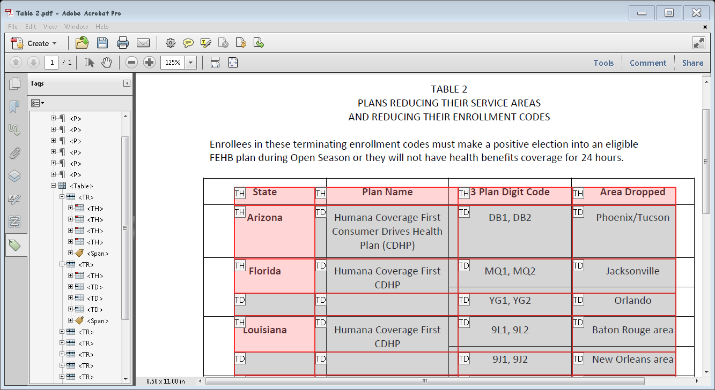

Do ensure tables are described and labeled when appropriate.
There are various ways to describe and label a table. The example below shows a captioning label.
Table 1: Simple table listing Department Schedule
Department Code | Class Number | Room Number
BIO | 100 | 5
BUS | 200 | 8
PSY | 300 | 12

Do ensure that the header row repeats at the top of each page when a table spans multiple pages.
When tables span multiple pages, it is important that the header row repeats at the top of each page to facilitate navigation.
Figure 2: Example of Header Row View When Table Spans Multiple Pages - Page 1
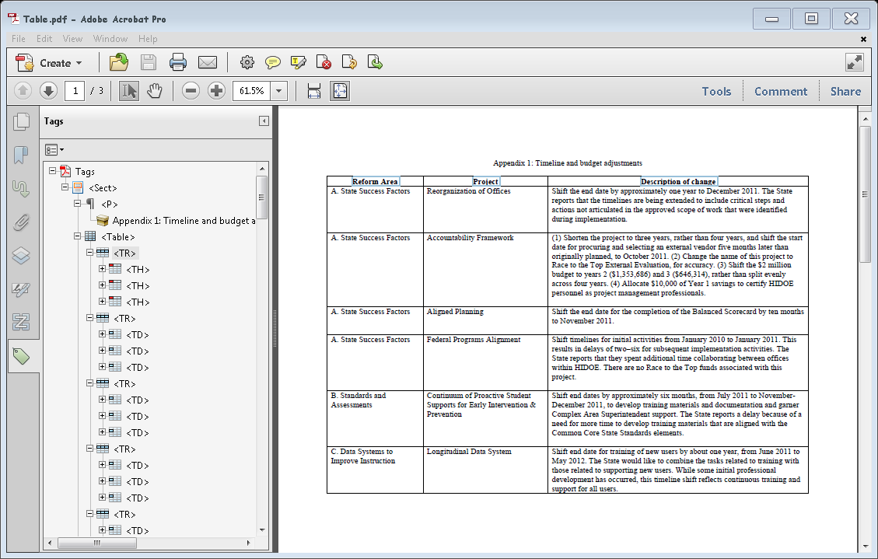

Figure 3: Example of Header Row When Table Spans Multiple Pages - Page 2
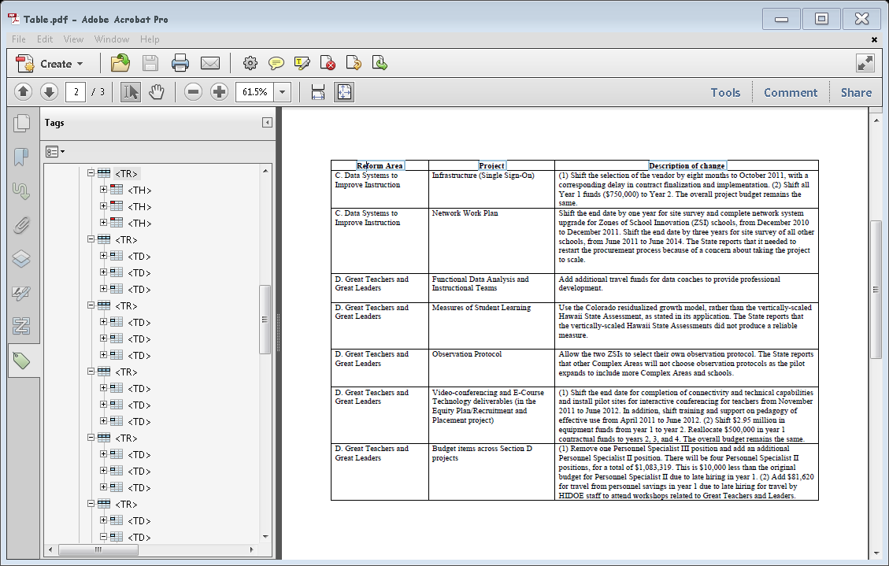

DO NOT:

Do not use tables with rows that break across the pages when the table spans multiple pages.
Ensure that the content contained in rows does not split if the table spans more than one page. Again, this containment aids in navigation.
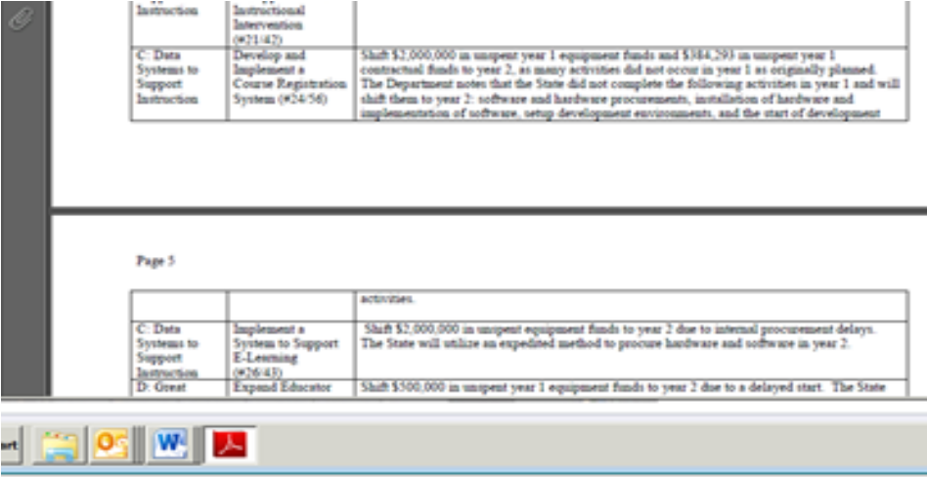

Do not use tables containing empty rows or columns.
When a screen reader comes to an empty row or column, it reads, “blank cell.” When the rows or columns are used for formatting purposes, a person using assistive technology will hear multiple times, “blank cell, blank cell, blank cell.” This makes understanding the document difficult. Therefore, it is important to use simple tables that do not contain empty rows or columns for formatting purposes.
Department Code | Class Number | Room Number
BIO | 100 | 5
BUS | 200 | 8
PSY | 300 | 12

Other

DO:

Do ensure that the PDF has the proper language assigned.
In PDF, you identify the language of the document by selecting File, clicking on “Properties”, clicking on the “Advanced” tab, and then making sure the appropriate language is listed under the Language menu located under “Reading Options”.
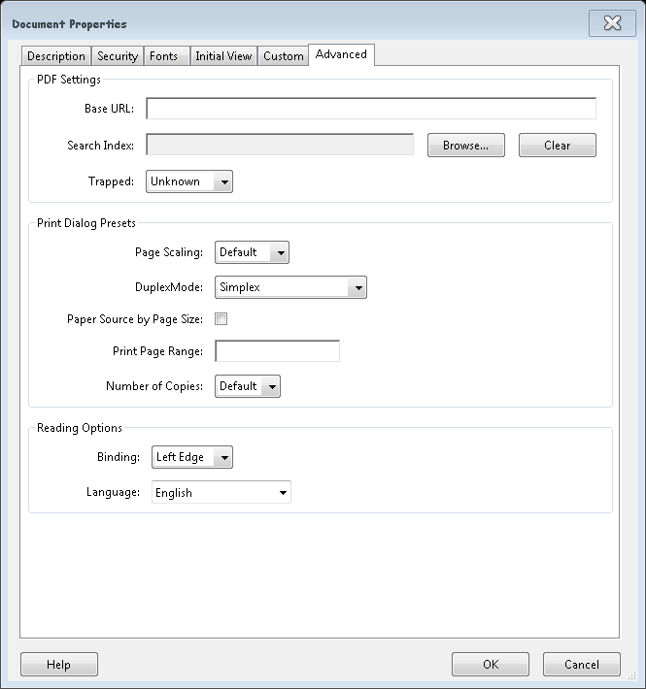

Do provide an alternative format, with equivalent information and functionality, if a document cannot be made accessible. This option should be used as a last resort.
Following these basic requirements will increase the accessibility of your documents, but it does not guarantee accessibility to any specific disability groups. In cases where more certainty is required, it is recommended that you test the office documents with end users with disabilities, including screen reader users, or send to the Assistive Technology Team for testing.
While basic requirements have been provided, more complex projects may have additional standards applied such as the technical standards in Section 508 in 1194.21, 1194.22, and 1194.31. If you are creating forms in a PDF Document please contact the Assistive Technology Team for additional information at OCIOATTeamGov@ed.gov or contact via phone at: 202.453.7320.
This document sets out basic requirements on making PDF documents accessible. We will continue to work on improving this document to make it even more user-friendly and ensure that it provides the most thorough and up-to-date information possible. Any feedback that you have on possible improvements would be appreciated and can be sent to Holly.Anderson@ed.gov.

This document has been a team effort. A huge thank you to everyone on the development team: Don Barrett, OCIO; Crystal Jones, OCIO; Terri Youngblood, OCIO; Christopher Coro, OVAE; Geoff Rhodes, OSERS; and Jim Richards, Training and Development.

